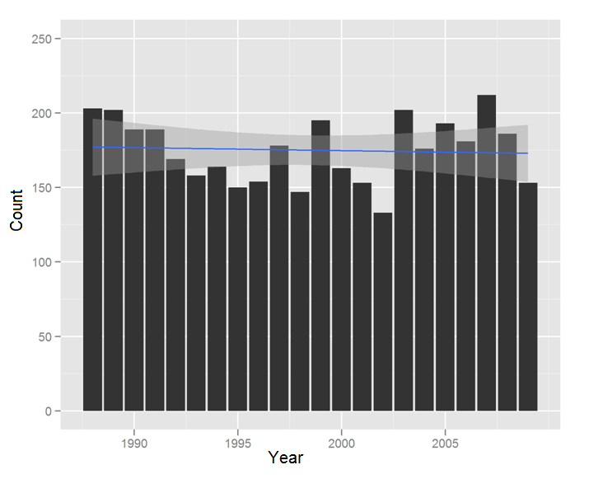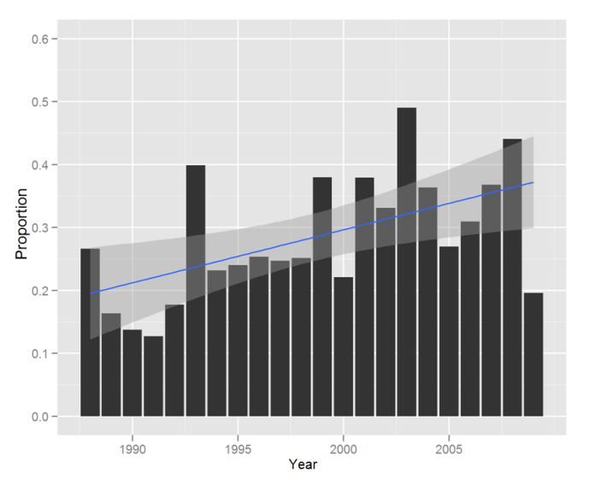

**Figure 1: The number of sinonasal cancer surgeries has not changed significantly over the last twenty years, but an increasing proportion of these surgeries are performed at high-volume centers. A: Total number of sinonasal cancer surgeries per year. B: Proportion of sinonasal cancer surgeries performed at high-volume centers per year.**

Supplemental Figures

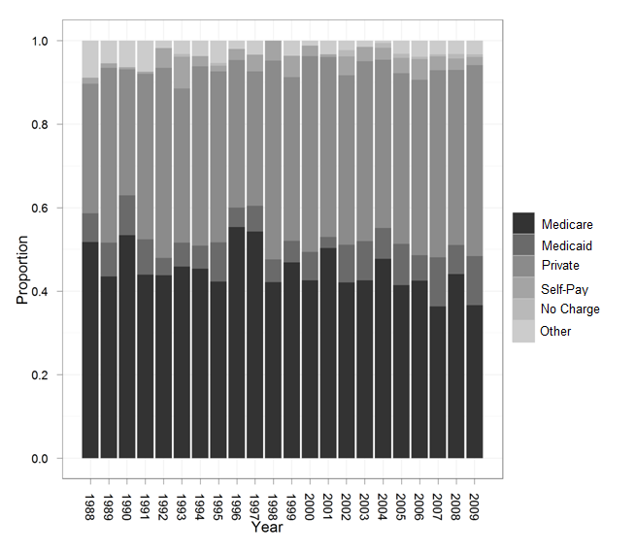

**Figure A: Sinonasal surgery patients’ insurance status has not significantly changed over time.**

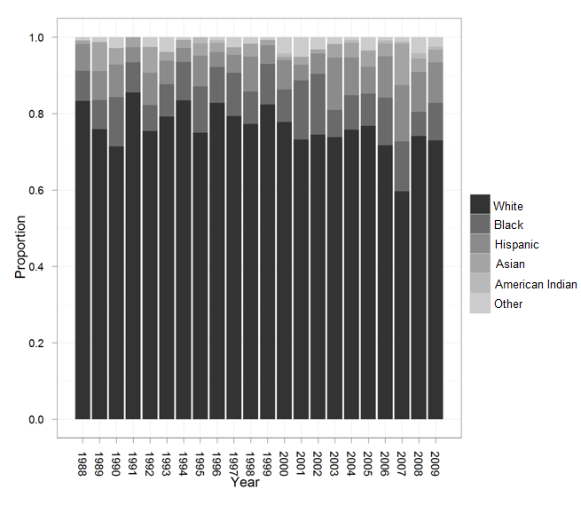

**Figure B: Sinonasal surgery patients’ race has not significantly changed over time.**

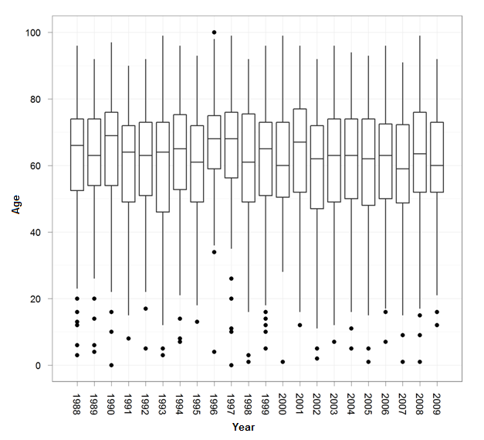

**Figure C: Sinonasal surgery patients’ age distribution has not significantly changed over time.**